**JENKINS**

Setting the PATH for Maven and Java in Jenkins tools is essential to ensure that Jenkins can locate and execute these tools during the build process. Maven is a build automation tool commonly used for Java projects. Configuring Maven in Jenkins:

First checking in the command prompt whether environment variables are set correctly.

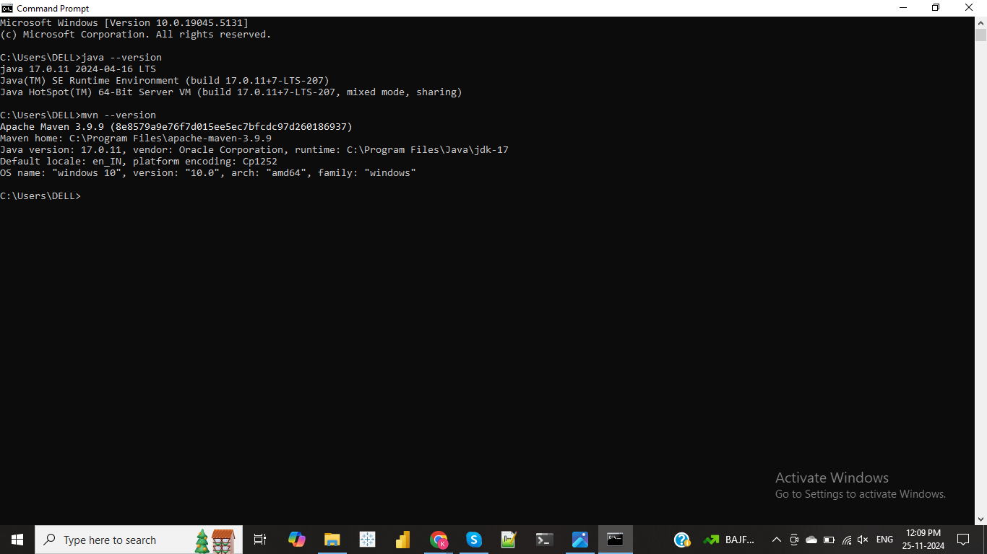

**JAVA PATH SETTING:**

**To set the path for Java**: Go to Manage jenkins -- Tools --JDK install -- ADD JDK and add the path which is located in system.

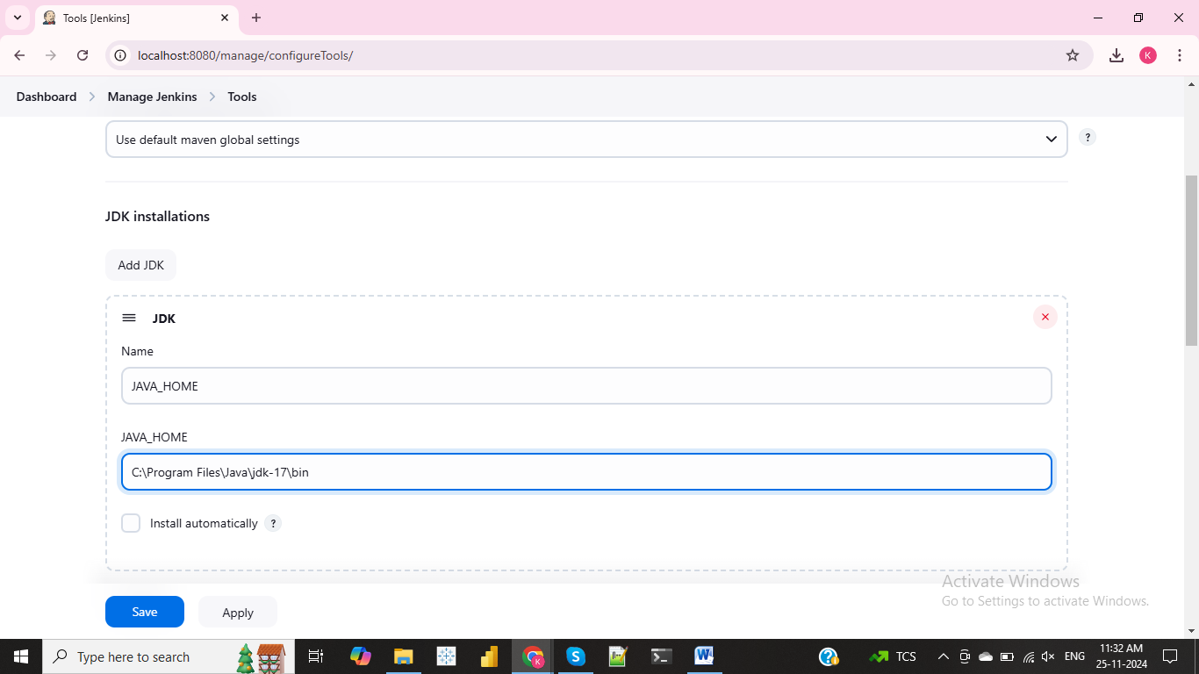

To check the path setting is correct: In Dashborad go to job which created then Go to build steps --select --Execute windows batch command “java --version” and then give apply and save and atlast build now option.

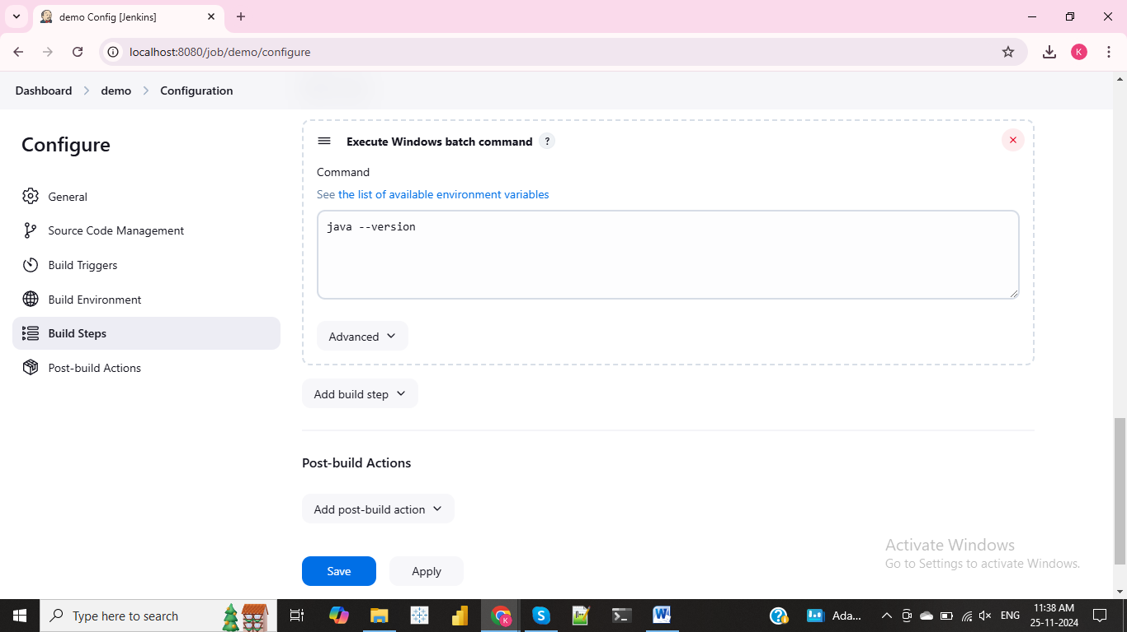

Output for Java build:

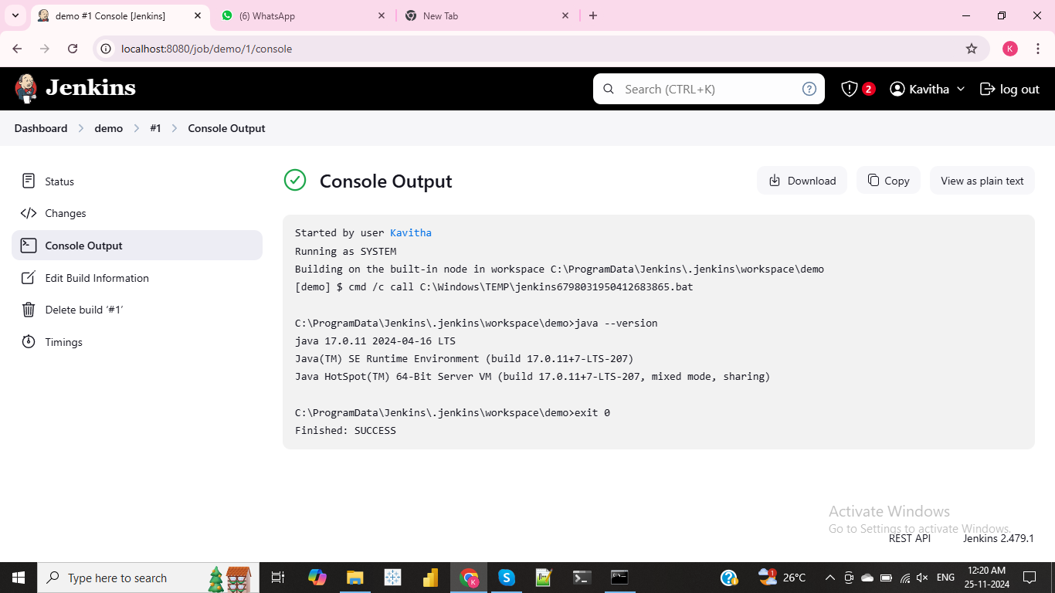

**MAVEN PATH SETTING**

**To set Maven path**:Go to Manage Jenkins--Tools--Maven installation and add the path.

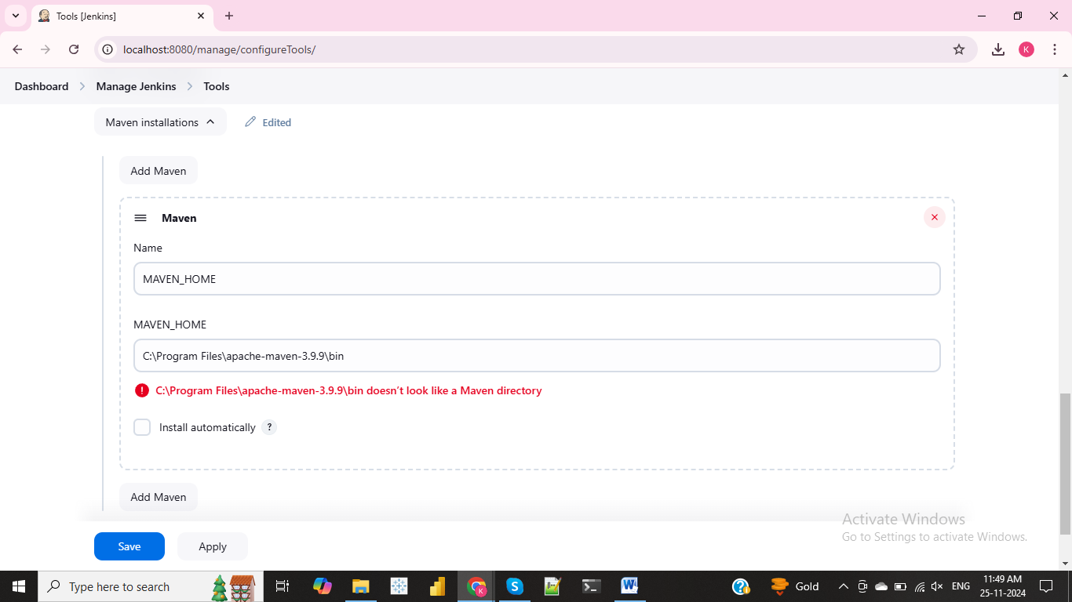Then go to Dashboard click the job and go to configure then to check the path setting:

Go to build steps --select --Execute windows batch command “mvn --version” and then give apply and save and atlast click build now option

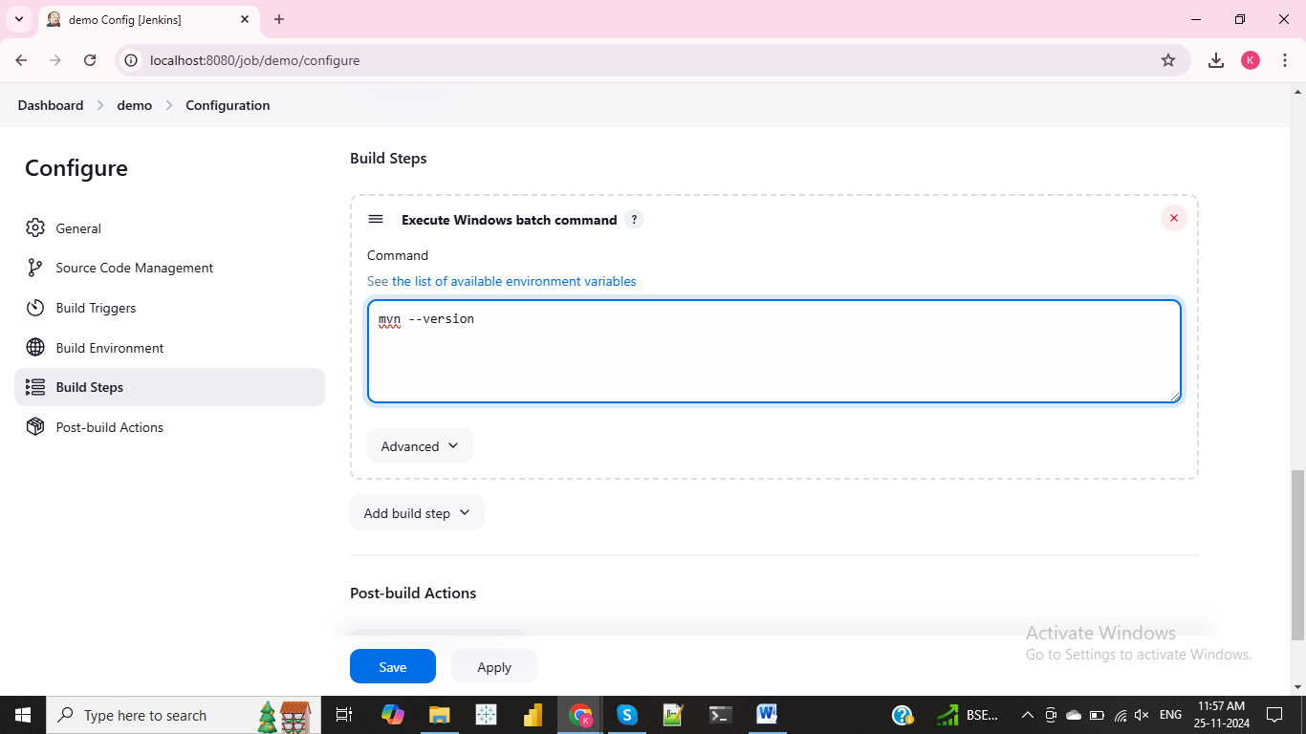

Output for Maven path success.

